THE GASOLINE VS. ELECTRIC CAR COMPARISONS
AND THE ECONOMICS OF VARIOUS HYBRIDS

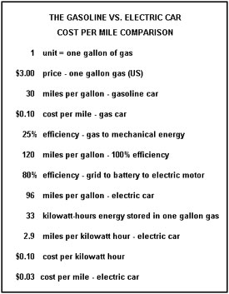

Economic and environmental performance comparison
among several popular hybrid models available in the U.S.^{[128]}
Vehicle | Year  model | EPA  City  mileage  (mpg) | EPA  Highway  mileage  (mpg) | Annual  fuel  cost ⁽¹⁾  (USD) | Carbon  footprint  (Ton/yr of  CO₂) | EPA  Air Pollution  Score⁽²⁾
Toyota Prius | 2010 | 51 | 48 | $732 | 3.7 | N/A
Toyota Prius | 2009 | 48 | 45 | $794 | 4.0 | 8
Ford Fusion Hybrid | 2010 | 41 | 36 | $937 | 4.7 | N/A
Honda Civic Hybrid | 2009 | 40 | 45 | $871 | 4.4 | 9
Honda Insight | 2010 | 40 | 43 | $893 | 4.5 | N/A
Nissan Altima Hybrid | 2009 | 35 | 33 | $1,076 | 5.4 | N/A
Toyota Camry Hybrid | 2009 | 33 | 34 | $1,076 | 5.4 | 8
Ford Escape Hybrid⁽³⁾ 2WD | 2009 | 34 | 31 | $1,146 | 5.7 | 8
Chevrolet Malibu Hybrid | 2009 | 26 | 34 | $1,263 | 6.3 | 6
Saturn Vue Hybrid | 2009 | 27 | 32 | $1,307 | 6.6 | N/A
Toyota Highlander Hybrid | 2009 | 27 | 25 | $1,409 | 7.1 | 8
Chevrolet Silverado Hybrid⁽⁴⁾ 2WD | 2009 | 21 | 22 | $1,742 | 8.7 | 6
Cadillac Escalade Hybrid 2WD | 2009 | 21 | 22 | $1,742 | 9.2 | 6
Chevrolet Tahoe Hybrid 2WD | 2009 | 21 | 22 | $1,742 | 8.7 | 6
Lexus GS Hybrid 450h | 2009 | 20 | 25 | $1,905 | 8.1 | N/A
Dodge Durango HEV | 2009 | 20 | 22 | $1,914 | 8.7 | N/A
Lexus GS Hybrid 600h | 2009 | 20 | 22 | $2,085 | 8.9 | 8.0
Source: U.S. Department of Energy and U.S. Environmental Protection Agency^{[128]}
Notes: (1) Estimates assumes 45% highway driving, 55% city driving, and 15,000 miles (24,000 km) per year,$2.68/gal
(2) All states except California and Northeastern states.
(3) Performance is the same for the Mazda Tribute Hybrid 2WD and the Mercury Mariner Hybrid 2WD
(4) Performance is the same for the GMC Sierra Hybrid 2WD, the Chevrolet Tahoe Hybrid 2WD, and the GMC Yukon Hybrid 2WD.

